 

Department of Computer Science & Information Technology

III Year,V Semester(Batch 2022-2026)

Lab Record Submission of

Linux (Lab)

Subject Code – CSIT-505

Submitted to: Submitted by:

Prof. Nidhi Nigam Tanishka Soni

0827CI221139

**Linux Lab file -2**

**Commands**

* **Man command**

Syntax- man (common name)

Description- This is the command itself, which invokes the manual page viewer.

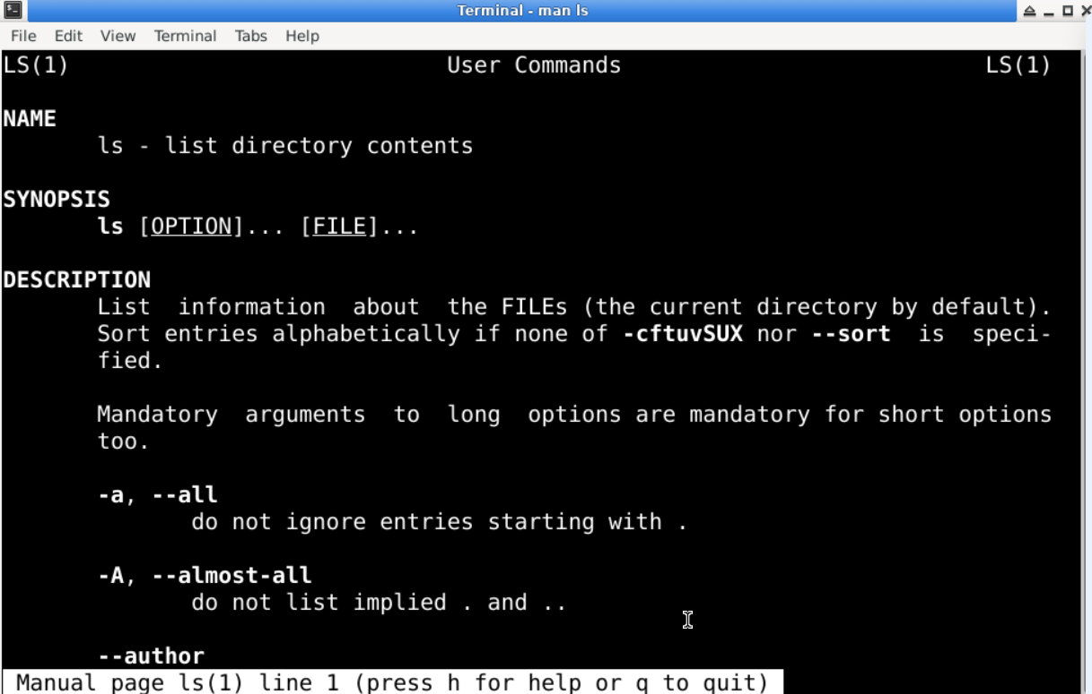

* **echo command**

Syntax- echo(statement)

Description: This is a built-in command in many shell environments, including Bash. Its primary function is to display a line of text or a variable value to the standard output (usually the terminal).

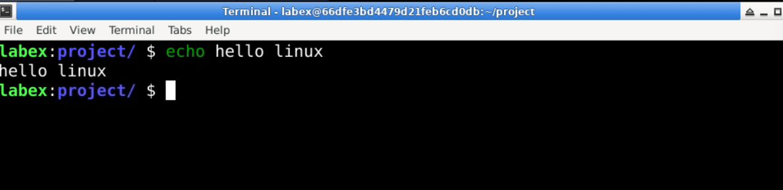

* **whatis command**

Syntax- whatis(command name)

Description- : This is the command itself, which queries the manual database for descriptions of commands.

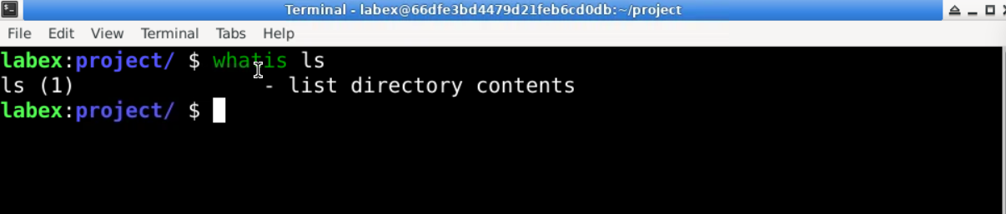

* **date command**

Syntax- date(command name)

Description- : This is the command itself, which retrieves and displays the current date and time.

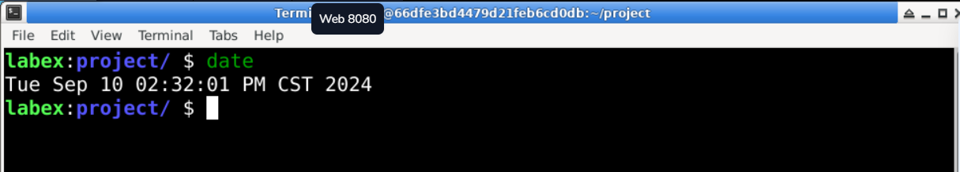

* **pwd command**

Syntax- pwd

Description- : This is the command itself, which outputs the full path of the current workingdirectory. 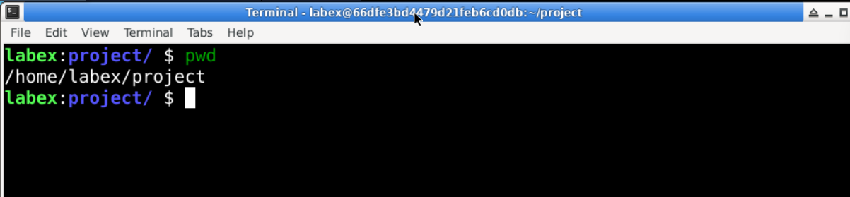

* **mkdir command**

Syntax- mkdir (directory name)

Description- : This is the command itself, which is used to create one or more directories.

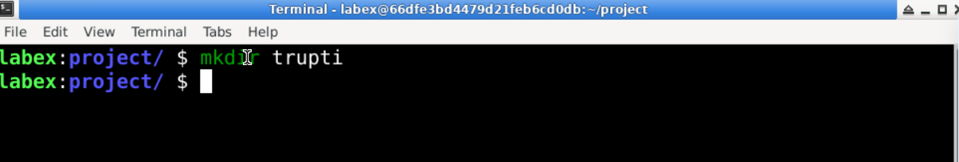

* **cd command**

Syntax- cd (directory name)

Description- : This is the command itself, which is used to change the current working directory.

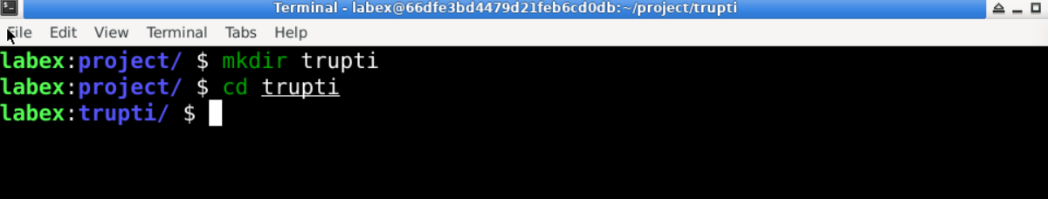

* **rmdir command**

Syntax- rmdir (directory name)

Description- :  This is the command itself, which is used to remove empty directories.

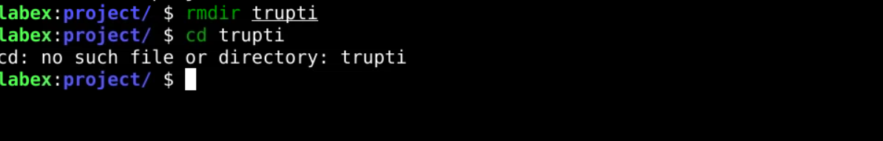

* **ls command**

Syntax- ls

Description- This is the command itself, which stands for "list." By default, it lists the files and directories in the current working directory.

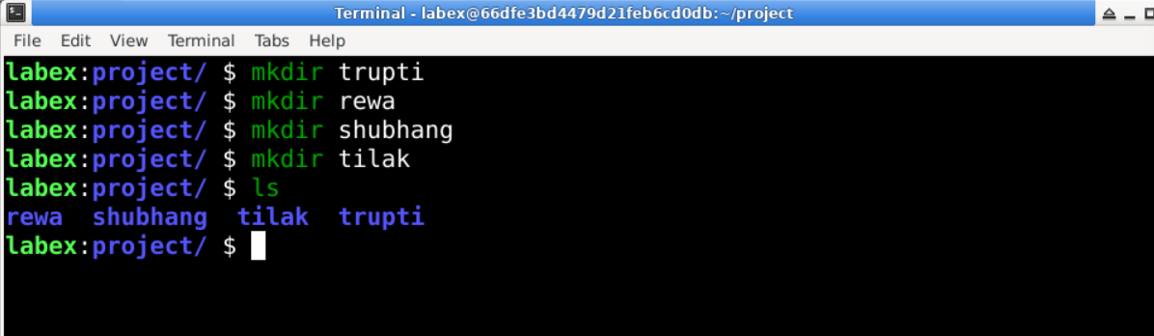

* **grep command**

Syntax- grep(file name)

Description- This is the command itself, which searches for patterns in text.

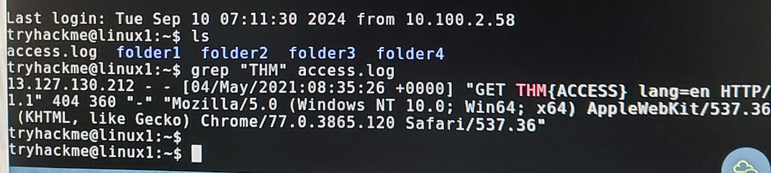

* **find command**

Syntax- find(file name)

Description- The find command is a powerful utility in Unix/Linux systems used to search for files and directories within a specified directory hierarchy

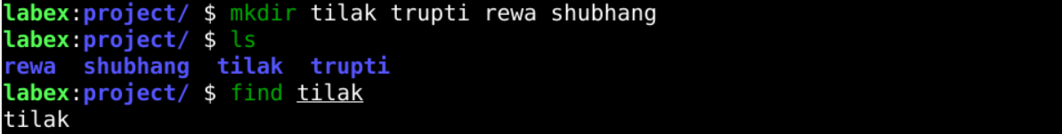

* touch command

Syntax- touch(file name)

Description- The touch command in Linux is used to create empty files or update the timestamps of existing files

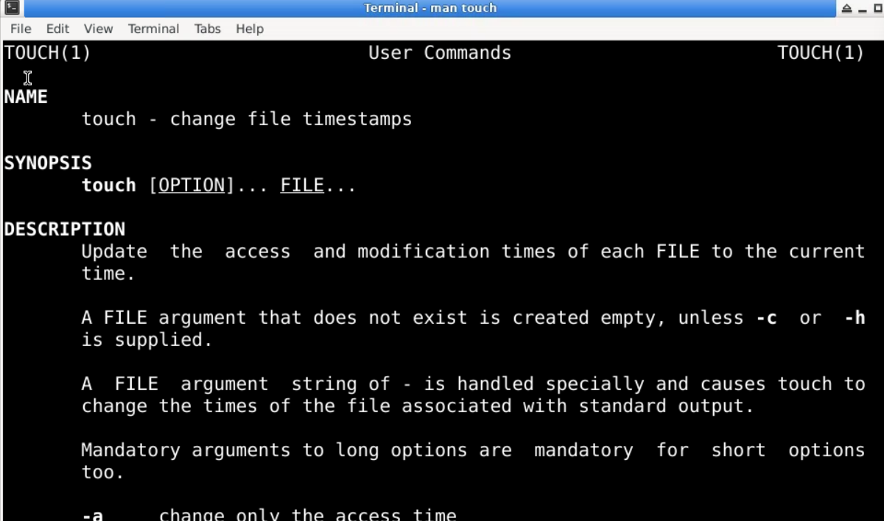

* ls -l command

Syntax- ls -l

Description- The ls -l command in Linux is used to list files and directories in a detailed (long) format.

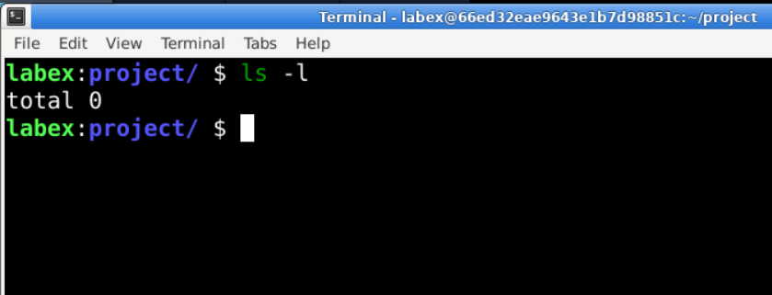

* cp command

Syntax- cp [options] source destination

Description- The cp command is a utility in Unix-like operating systems used to copy files and directories.

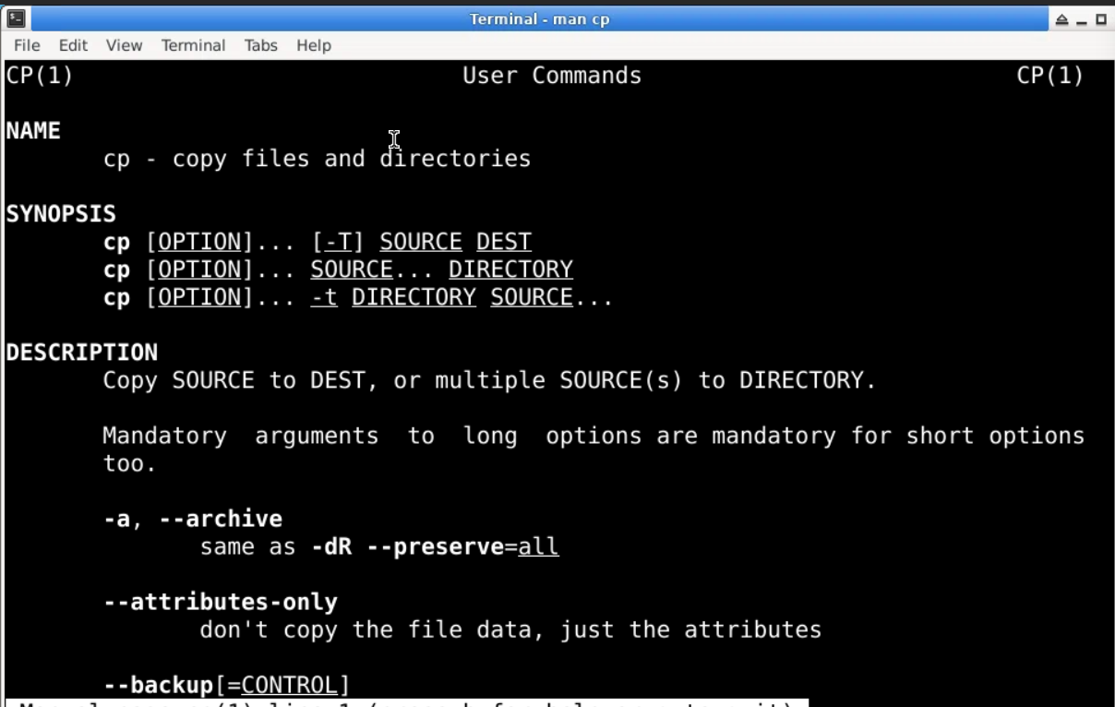

* ls -a command

Syntax – ls -a

Description - The ls -a command in Linux is used to list all files and directories in the current directory, including hidden files.

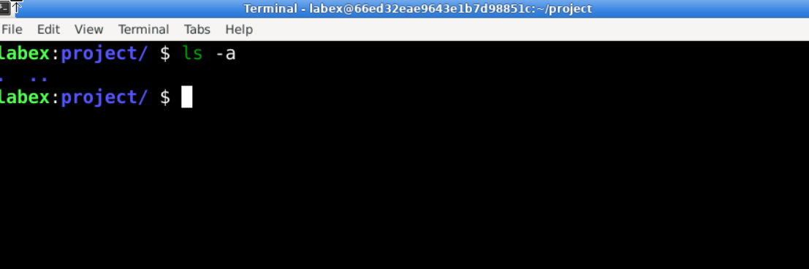

* mv command

Syntax- mv (file name)

Description- The mv command in Linux is used to move or rename files and direc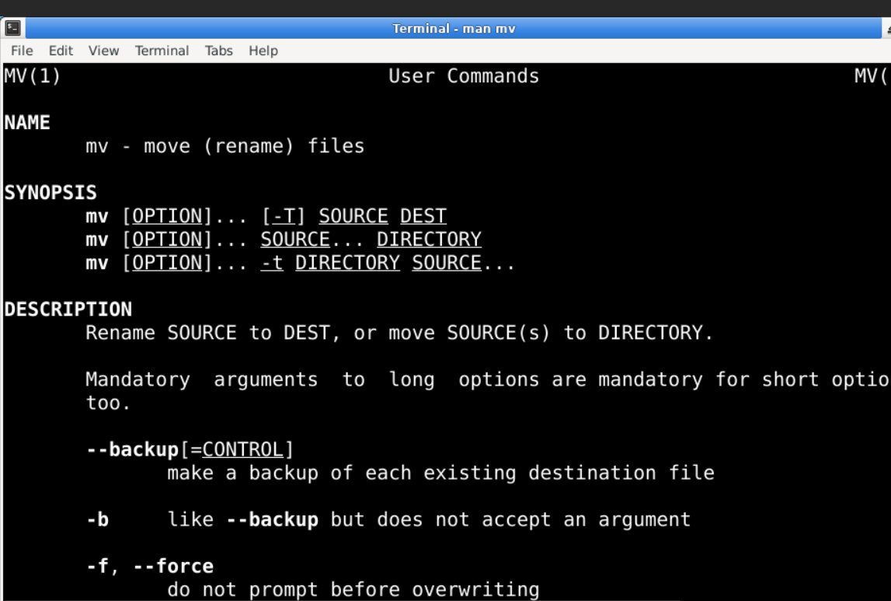

* less command

Syntax- less (file name)

Description- The less command is a commonly used command-line utility in Unix-like operating systems for viewing the contents of files one screen at a time

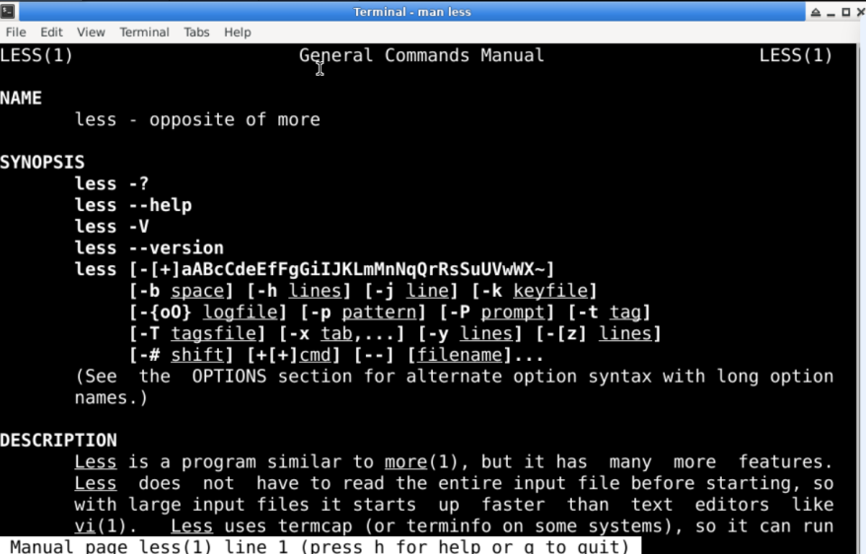

* ps command

syntax- ps

description- The ps command is used in Unix-like operating systems to display information about the currently running processes.

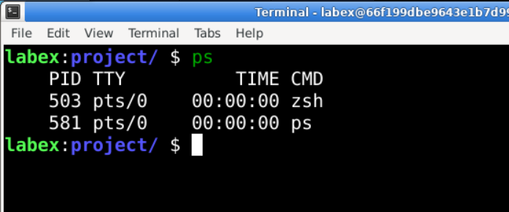

* kill command

syntax- kill [optin] <pid>

description- The kill command is used in Unix-like operating systems to terminate processes

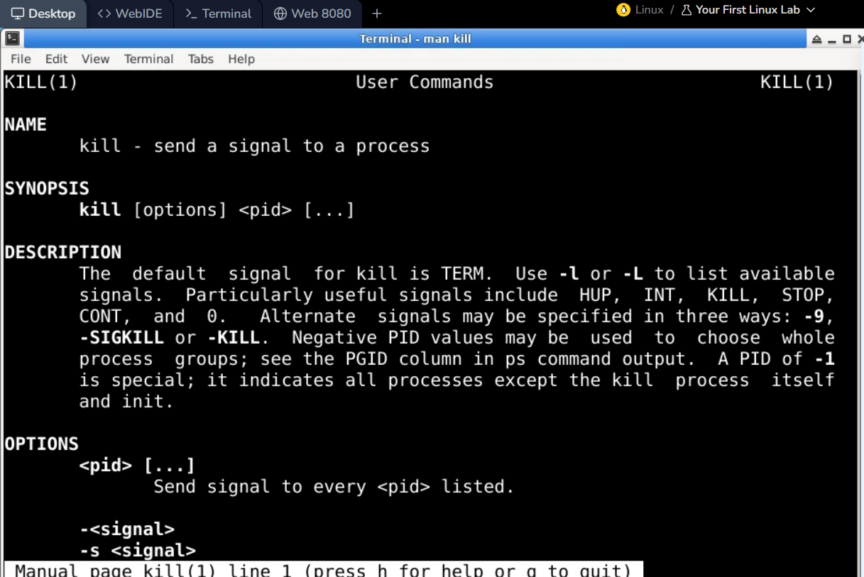

* ip

syntax-ip

description- The ip command is a powerful utility in Linux and Unix-like operating systems used for managing network interfaces,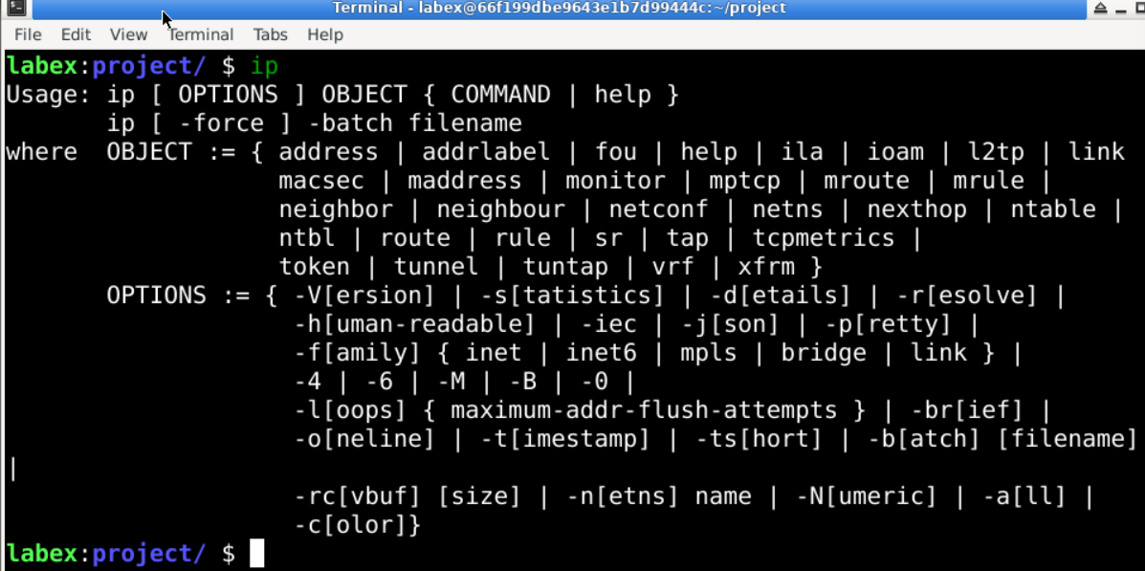

* ifconfig command

syntax= ifconfig

description- The ifconfig command is a network utility in Unix-like operating systems used to configure and display network interface parameters.

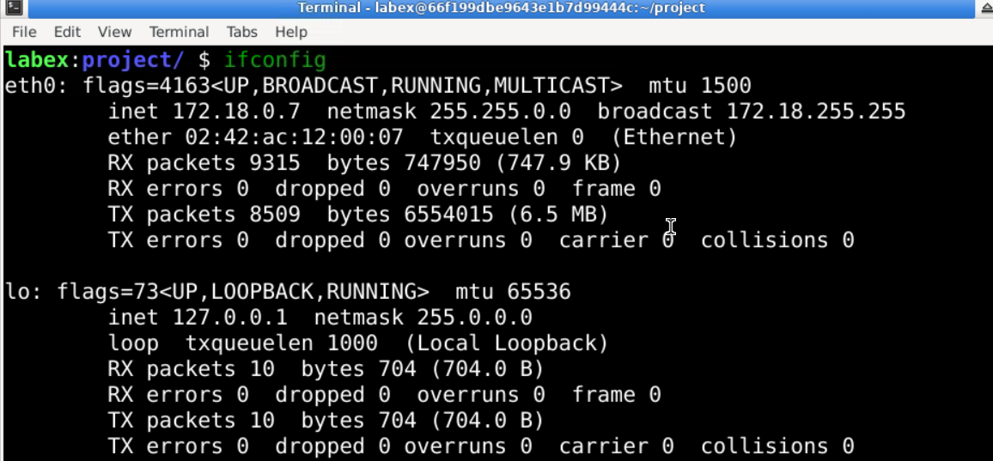

* head command

syntax- head (file name)

decription= The head command is a utility in Unix-like operating systems used to display the beginning of a file or standard input.

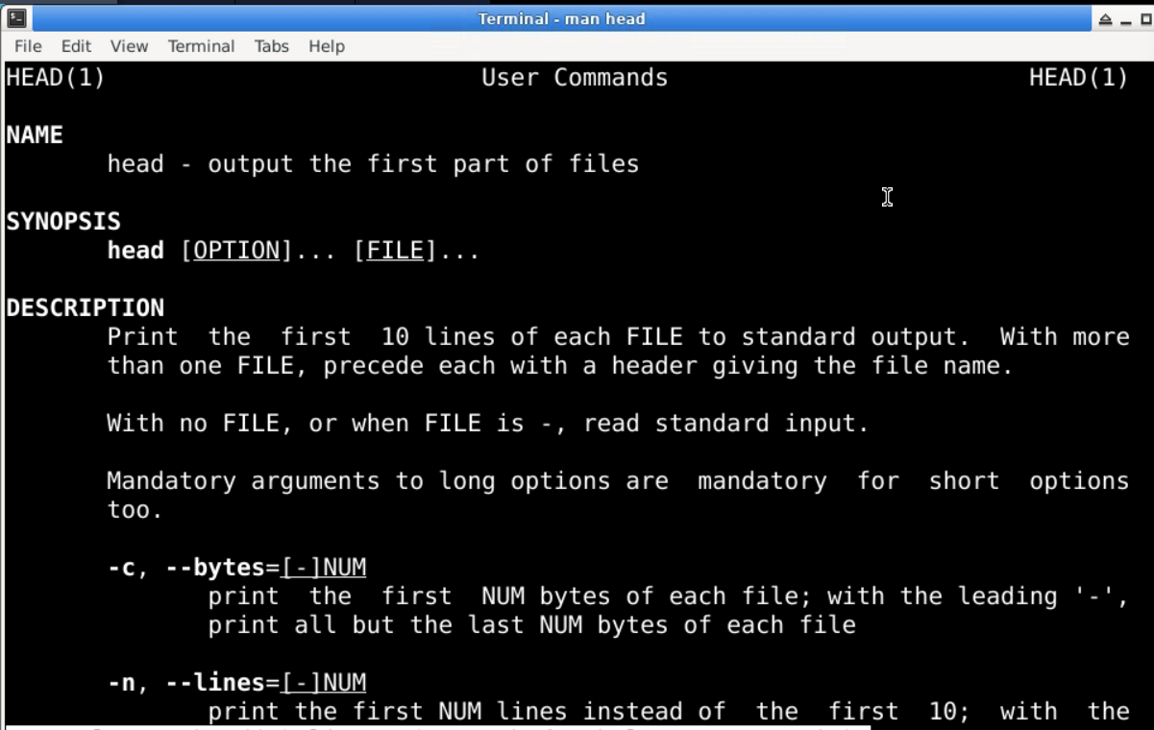

* tail command

syntax- tail (filename)

description- The tail command is a utility in Unix-like operating systems used to display the end of a file or standard input

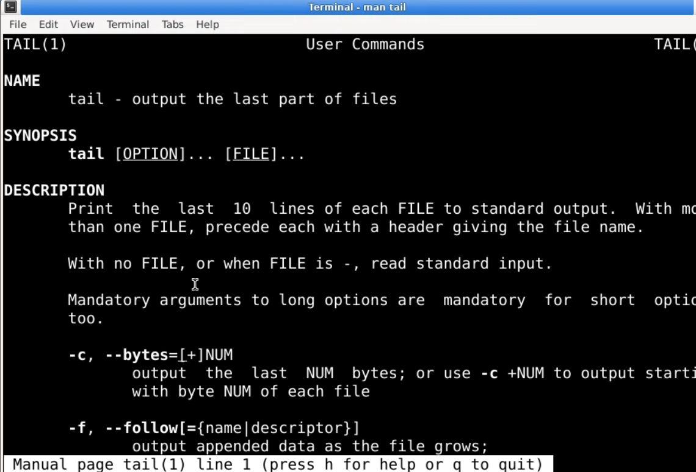

*THANK YOU!!*